**Recorded Courses System**

1. **Define Scope(**Recorded Courses System**)**
2. **Mandatory Object**

* Admin
* Instructors
* Course

1. **The Software Type and the functionality follow in the system (Customize)**

* Admin should be available before anything
* Admin will login the system
* Admin should be able to add Instructors (Email,Password,Profile Image,Bio)
* Admin should be able to edit the Instructors Info (Email,Password,Profile Image,Bio)
* Admin should be able to explore Instructors (Email)
* Admin should be able to deactivate/active Instructors account
* Admin should be able to add courses (title,description,category,level,piece,discount,total duration)
* Admin should be able to edit the courses (title,description,category,level,piece,discount,total duration)
* Admin should be able to explore the courses (title,category,level,price)
* Admin should be able to deactivate/active the courses
* Admin should be able to add category (title)
* Admin should be able to edit category (title)
* Admin should be able to explore the category (title)
* Admin should be able to deactivate/active the category (title)
* Admin should be able to set the Price Plane (price , discount)
* Admin should be able to Generate analytics reports on revenue (total price)
* Admin should be able to Generate analytics reports on enrollments (lessons)
* Admin should be able to Generate analytics reports on instructor performance (rating)
* Admin should be able to explore learners
* Admin should be able to deactivate/active learners account
* Instructors should be able login (email,password)
* Instructors should be able to upload the course (title,description,category,level,piece,discount,total duration)
* Instructors should be able to add lessons (video file,title,duration)
* Instructors should be able to set price (price)
* Instructors should be able to view a course performance enrollments by (report)
* Instructors should be able to view a course performance reviews by (report)
* Instructors should be able to view a course performance ratings by (report)
* Instructors should be able logout
* Learners should be able to login (Email , password)
* Learners should be able to browse the course (title , category , level)
* Learners should be able to search the course (title , category , level)
* Learners should be able to filter the course (title , category , level)
* Learners should be able to enroll in the course (title , category , level)
* Learners should be able to track progress in the course (title , category , level)
* Learners should be able to add bookmark for the favorite course (title )
* Learners should be able to give a reviews
* Learners should be able to Has a Subscription_Plan
* Learners should be able to explore a Course_Bundles
* Learners should be able logout

1. **Summarize the Objects (Abstraction)**

* Commun attribute (id , CreatedBy , UpdatedBy , CreationDate , UpdationDate , isActive)
* Admin (FullName , Email , Password)
* Instructors (Email , Password , Profile Image , Bio)
* Learners (Email , Password , Profile Image , Bio)
* Courses (title ,description ,category,level, price,discount,total duration)
* Lessons (video file , title , duration)
* Course_Bundles (title, description , price, discount)
* Subscription_Plan(price,name, duration)

1. **Summarize the Objects Relationships**

* instructors (1:M) Courses (create)
* learners (M:M) Courses (Enroll)
* learners (M:M) Courses (BookMark)
* learners (M:M) Courses (Review)
* learners (M:M) Course_Bundles (subscription)
* learners (M:M) Lessons (Status tracked)
* learners (M:1) Subscription_Plan (Has)
* Courses (1:M) Lessons(Has multiple)
* Courses (M:M) Course_Bundles (Included In)

1. **Implement ERD Diagram**

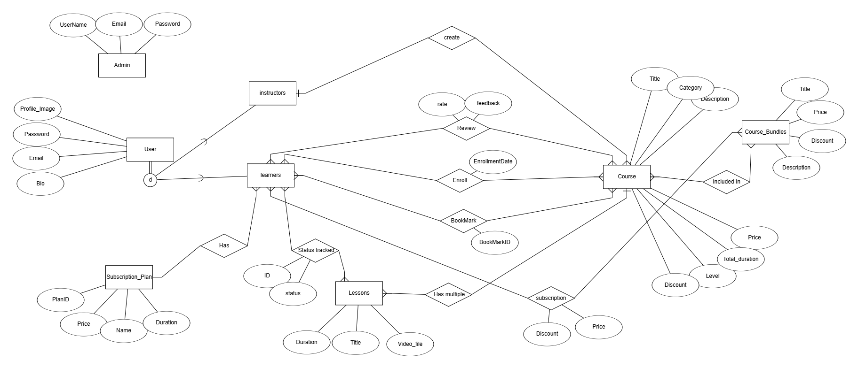

1. **Implement Relation Schema**

